

Triumph GT6 / Vitesse
5-Speed Gearbox Conversion

Fitting Instructions

- Remove the gearbox in accordance with the workshop manual instructions. It is advisable to remove the slave cylinder from the original gearbox and leave on the car so avoiding the need to bleed the slave cylinder when reassembling.
- Remove the speedo cable.
- Remove the seats, carpets and transmission tunnel cover from the car.
- Remove the old spigot bush from the deeper recess of the crankshaft and discard. If this is tight in the crank you can either use the hydraulic method (Pack the spigot bush with grease then insert a tight fitting shaft & hit the shaft. This should force the bush out under the hydraulic pressure.) or cut a slot in the old spigot bush using a thin hacksaw blade or a small drill bit by drilling along the bush and when the slot is complete you will be able to remove the bush with a screwdriver and pointed pliers.
- Fit the new spigot (oilene) bush into the flywheel. Lubricate the bush very lightly with grease.
- Remove the old clutch kit. Fit the new clutch assembly using a clutch aligning tool and tighten down in accordance with workshop manual instructions. Note: Make sure that the clutch plate is fitted the correct way round with the raised centre boss of the clutch plate facing towards the gearbox.
- Remove the bellhousing from the gearbox. Remove the clutch release arm and bearing from the bellhousing.
- Offer the adaptor plate up to the back of the bellhousing. It will foul a small amount of the casting next to the original clutch slave cylinder mounting. This should be removed with a saw or similar tool to sufficiently allow the plate to sit completely flush with the bellhousing.
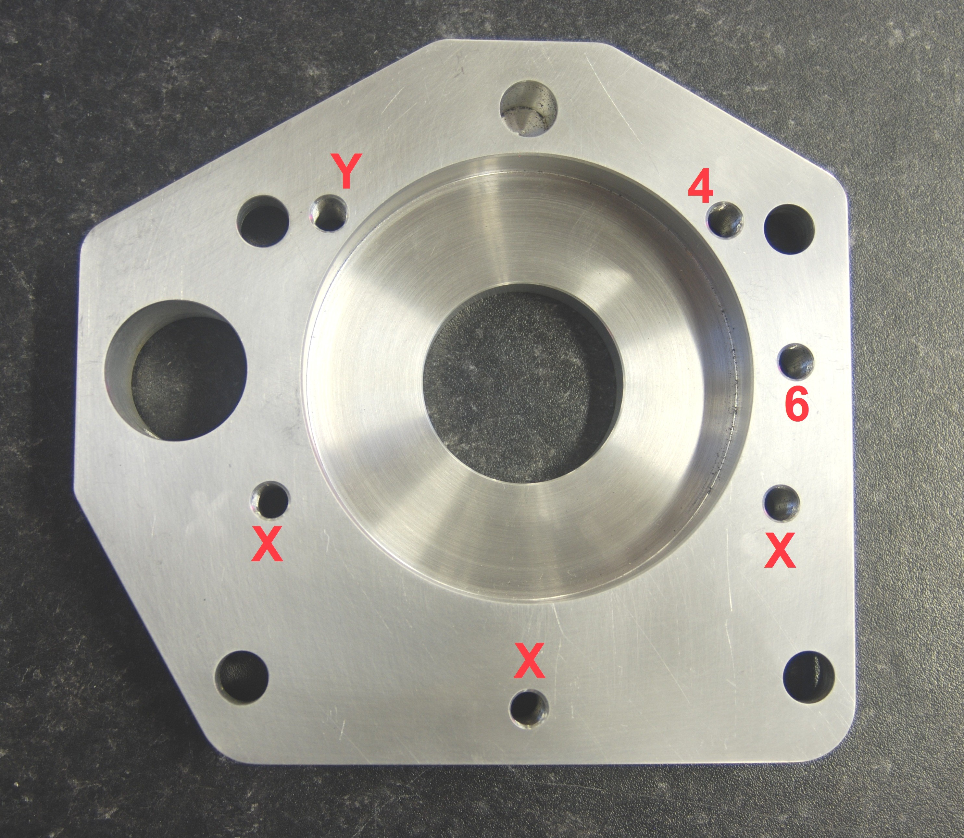

Adaptor Plate:

Hole 4 is for use on 4 cylinder engines
Hole 6 is for use on 6 cylinder engines
Hole Y is used on both 4 and 6 cylinder engines
- Bolt the new adaptor plate to the bellhousing using the three bolt holes, marked X, which line up with three of the existing holes in the bellhousing. From the back face of the new adaptor plate you will have three 3/8 threaded holes that do not line up with any holes in the bellhousing: For the GT6 and Vitesse conversions use hole Y and hole 6 and drill 2 holes in the bellhousing as follows:
- Take a drill that is a good fit in these holes and make a spot mark through them onto the bellhousing. Remove the adaptor plate. Now drill through the bellhousing, where you have
marked with the drill, making the hole large enough for the bolts supplied to pass through freely. (Accuracy is not critical here as the alignment is taken care of by the adaptor plate.) Once the holes are drilled you may have to file or grind the area around the newly drilled holes inside the bellhousing to give a level surface for the bolt head to pull up against. You should now have five holes that line up between the adaptor plate and the bellhousing.
- In the centre of your bellhousing there is a small guide tube on which the bearing is designed to run. The internal bore of this tube will probably need enlarging to 27mm or larger to allow clearance when assembling the bellhousing onto the gearbox and passing over the first motion shaft. This can be done with a round file, or by reaming or drilling out if you have the facilities.
- Now bolt the adaptor plate to the gearbox. Add a smear of instant gasket around both the gasket and the adaptor plate then fit to the gearbox using Loctite or similar on the bolts supplied. If section 11 has been carried out correctly, the new adaptor plate will easily sit flush against the gearbox.
- Refit the bellhousing to the adaptor plate, which is now bolted to the gearbox.
- Refit the clutch release arm and bearing.
- Use the connectors supplied to make up a small sub loom to connect to the existing reverse light wires. Connect to the reverse light switch on the gearbox when installing it in the car.
- Bolt the new rubber mounting to the gearbox.
- Remove the old gearbox mounting plate.
- Fit the new mounting plate to the underside of the chassis so that the front holes in the plate line up with the rear ones on the chassis. From below drill the rear mounting holes in the chassis using the new plate as a template. Because the chassis rises up towards the rear, spacer washers are needed to fill the gap. These are supplied. Use as required and bolt the plate in place.
- Refit the gearbox to the engine in accordance with the workshop manual and install in the car. Make sure that the assembly is in the operating position and aligned front to back and not fouling the body at any point. Pay close attention to the following:
• The flanges on the chassis legs may be very close to the side of the gearbox. If they are, mark them and cut away as necessary (allow around 10mm of clearance which will allow room for any movement of the engine or gearbox). If modifications are necessary to the chassis legs they may require re-welding to ensure the strength is maintained. If only a small amount of additional clearance is required, a spacer can be placed under the gearbox rubber mount to raise the gearbox up to give this clearance.
• The gear lever position on the gearbox has been modified to bring it closer to the original position. The new position will be approximately 1" further back than standard. Some modification to the transmission tunnel cover will be required to accommodate the new gear lever position. This is best done by cutting your tunnel cover just to the rear of the H section and inserting a 2" wide strip between the two halves. We use aluminium but plastic or steel will also work well. Secure this by riveting it and bonding it to both halves of the tunnel cover. Always do a trial installation to check the position relative to the gear lever before finalising the modifications. Look carefully at the rear extension of the gearbox and ensure it does not touch, or is not too close to, the tunnel or chassis. Cut the front of the tunnel back as necessary. It is important to maintain a clearance of at least 10mm in all areas. When you are happy that this is done, proceed with the installation as below.
Please seek advice on the above modifications if you are unsure.
- With the gearbox bolted to the engine and sitting centrally in the car, the rubber mount on the gearbox should be sitting on the new gearbox mounting plate. Using the bolts supplied, this can now be bolted into place.
- Refit the slave cylinder. Bleed the hydraulics if required.
- Now fit the propshaft from the rear axle end of the tunnel taking care not to get any dirt on the propshaft end as this may damage the oil seal in the rear of the gearbox.The new speedometer cable has to run over the chassis leg and under part of the floor pan on the O/S of the gearbox. To allow this, a small piece of the floor pan will need cutting in line with the new position of the speedo cable (the floor pan is not a structural member). With a cut made in the appropriate place the cable can be fitted.
- Connect it firstly into the speedometer head and then into the gearbox end. When you insert the cable inner into the drive gear in the gearbox, make sure that it is engaging with the drive gear before fitting the circlip retainer.
- Fill the gearbox with approximately 1.5 litres of semi synthetic 75/90 gear oil. Allow the oil to settle for 5 minutes then re-check.
- Refit the tunnel cover and carpet.
- Fit the gear lever.
- Refit the gear lever gaiter making sure that the rubber does not restrict the gear lever movement.
- Fit your chosen gear knob.
- Check the operation of the clutch mechanism and make any adjustments necessary to the clutch operating system by sliding the slave cylinder in or out of the adaptor plate.
- Now you should be ready to test the conversion. Make sure you are happy that everything is where it should be and all fixings are tightened securely.

Now all that remains is to try it!!!

Have Fun

R
1
3
5
4
2

Speedometer recalibration
Once the kit is installed your speedometer may require recalibration. This can be done by any reputable instrument refurbisher, such as Speedy Cables Ltd in the UK. Their web site at www.speedycables.com/calibration.html gives details of what is involved.

Trouble shooting
- If you get excessive noise or vibration, the probable cause is the gearbox or engine touching the body somewhere.

If you are in doubt please call us. It is better to take a little more time now than to have problems later. We are here to help.

