

MGB 5-LINK REAR SUSPENSION CONVERSION

The Frontline 5-link rear suspension system has been designed to completely replace the original rear suspension set up with fully-adjustable, coil-over dampers units.

We have used state-of-the-art processes and technology to produce a bolt-on conversion that transforms the ride quality, handling and traction of your car.
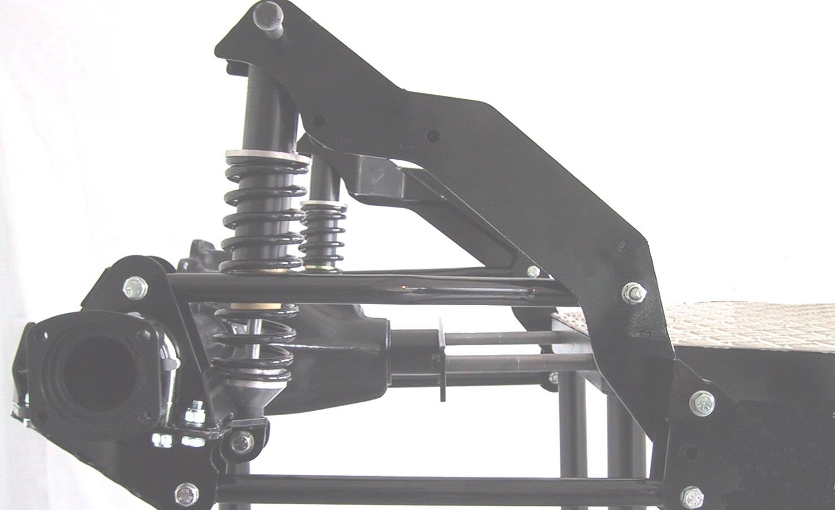

The conversion consists of parallel trailing arms, axle and body locating brackets, coil-over adjustable dampers and a panhard rod

Before starting we recommend that you familiarise yourself with the components by laying them out in their correct positions.

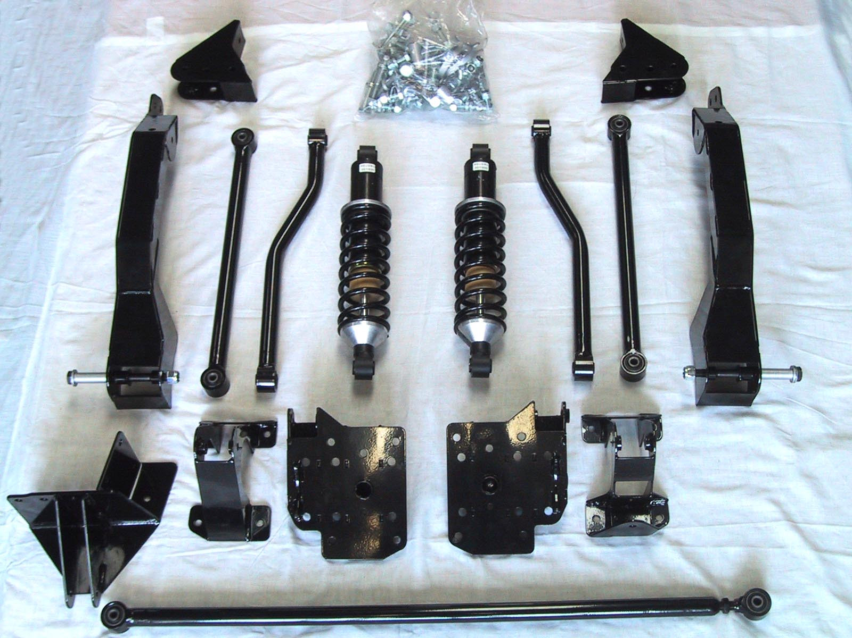
Panhard rod
Sub frame
Coil over dampers
Panhard rod body mounting bracket
Twin trailing arms
Top axle bracket
Lower axle bracket
Spring hanger bracket

Fitting instructions
(See pictures A to O on separate sheet)

Jack the rear of the vehicle and support on axle stands. With the axle hanging, remove the rear wheels. Then position the jack under the diff so it just supports the weight of the rear axle. Ensure the axle stands are stable and wheel chocks are in place at the front.
We advise that you complete the removal of the existing suspension and
the installation of the new kit one side at a time.
- Remove the lever arm top mounts.

- Undo the U bolts securing the leaf springs and lever arm plates to the axle and remove along with the bump stop plates on top of the axle.

- Undo the front spring hanger bolts to remove the spring eyes.

- Remove the rear shackle bolts to complete the removal of the leaf springs from the car.

- On rubber bumper models a stiffening web is found inside the front spring hangers and needs to be removed to give clearance for the lower trailing arm brackets. (A & B)

- Fit left and right sub frames in position using 7/16" bolts through the existing lever arm mounts. (Also, see 15.)

- The top damper mounts need to be drilled through with care using the template bracket supplied (I, J, K &L). (Note: The holes must be at 90° to the inner arch or they may not line up with the sub frame.) Drill through the wheel-arch, as shown, using a 10mm drill to meet the damper mounting holes in the sub frame. Then enlarge the outer hole only to 14mm to accept the flanged anti crush spacer provided.

- Put the new spring hanger bracket in position, with the larger trailing arm lugs positioned towards the centre of the car, and bolt through the spring hanger and sub frame as shown (C). This provides a position for the drilling of the holes through the floor. If the fit is to a rubber bumper car a spacer is required between the spring hanger and the spring hanger bracket. This is for the holes in both the original and new spring hanger and the new sub frame to line up. Two 8mm plates per side are provided for this, with rubber bumper kits, to be used as necessary.
Note: On chrome bumper cars, only the top and bottom holes line up with the spring hangar bracket. On rubber bumper cars, only the middle and bottom holes will line up.
Note: There is sometimes a misalignment between the holes on the original spring hangers and the new brackets. The spring hangers can move over time or your car may have had welding work done to it. The new sub frame brackets bolt to the existing lever arm mounting holes. These are consistently positioned on the car and we use these as our datum point. If you have a misalignment then align the new spring hanger brackets with the new sub frame brackets and modify the spring hangers accordingly. Please call if you would like advice.

- Drill holes through the floor of the car using the sub frames and spring hanger brackets as drilling guides. Two holes are located in each sub frame upper trailing arm mount and two are located in each spring hanger bracket (D). Once the holes are drilled, use 10mm bolts, nuts and washers and tighten to the recommended torque. (Note: make sure you remove all carpet and trim in the areas where you are drilling.)

- Support the axle and grind off the small tab on the front of the axle (E) as well as the droop strap mount on the axle carrier (F). The brake pipe needs to be manoeuvered out of the way of the top and bottom axle brackets for the fit (G). We recommend replacement of the brake line after the fit. Ensure that the area is free of dirt and debris before test fitting the top axle bracket. The bracket should slide freely over the axle and face up to the lower axle bracket easily. If satisfactory remove the bracket as this will be installed later in the fit.

- Put the lower axle bracket up into position using the three U bolts provided. The bracket will locate on the hole in the centre of the leaf spring seat on the axle via the boss in the axle bracket. As the U bolts are tightened the bracket will square up. Be sure not to over tighten the U bolts at this stage as the axle bracket is not fully stiff without the upper axle bracket attached and will bend. Once the lower axle bracket is firmly in position two holes are to be drilled in the bottom of the leaf spring seat (H) using the holes already in the lower axle bracket as guide holes. Before drilling check to see if the four 10mm holes in the upper axle bracket line up with the holes in the bottom axle bracket and that bolts can be inserted freely.
Note: The top axle brackets are handed. The L/H bracket has an additional locator for use with the MGB RTL. This locator is not required when fitting the panhard rod.

- After drilling, clean off debris and bolt through the newly drilled holes in the spring seat, with the M8 bolts provided, tightened to the correct torque.

- Fit the top axle bracket using the four M10 bolts provided. Once the bolts are tightened the three U bolts can be tightened fully.

- The trailing arms can now be fitted. The top arms are bent to give clearance to the spring and the damper. The longer straight section is fitted towards the axle end.
- Fit the coil over dampers. These should be placed with the adjuster screw facing forward and at the bottom of the damper.

- Bolt the panhard rod body-mounting bracket into position on the left hand side of the car using the droop strap mounting point on the body as a location guide (M). The hole in the panhard rod body-mounting bracket is oversize to allow for variances in the different models of MGBs. Remove any underbody seal or debris that might prevent the bracket from sitting firmly against the underside of the boot floor.

- Using the bracket as a drilling guide, drill through the boot floor to provide fixing holes. Fix into position using the load spreading plates and the M10 bolts provided (M, N & O).

- Fit the panhard rod to the axle using the new bracket on the RH side of the axle and to the chassis using the new bracket you have just fitted. The axle is now located laterally. (Note: The panhard rod body mounting bracket has two height position holes. In most cases we recommend using the lower hole. The upper hole is for use where your car’s handbrake cable runs too close to the panhard rod. Using the upper hole avoids the potential for interference.)
- Finally, check and tighten all fixings and lock nuts securely.

- Refit the road wheels and lower the car to the ground.

- Check the ride heights on both sides and adjust so that the ride height is approximately 20mm higher at the rear than the front, measuring from the bottom edge of the sill.

- Setting up the panhard rod: With the car on the ground, measure to a known point on either side of the car to check what adjustment is required to centralise the axle. The brake drum lip and the bump stop seat provide convenient measuring points. Adjust the panhard rod until the axle is centralised.

When first testing your new suspension we recommend you take time to get used to the difference. As initial damping settings we recommend that you start with the adjustment knob positioned fully clockwise to the hardest setting. Then turn it back 8 clicks. You can then adjust the damping rates one click at a time, either anti clockwise for softer or clockwise for harder, to allow you to set the car up to your personal requirements. We suggest that trying out the limits of this, and any other product, should be done in a safe place.

After the initial tests we strongly recommend re checking all fixing points and further tightening if required.

Once fitted and in regular use, the suspension should require little or no maintenance for a considerable period of time, but periodic checking of the trailing arm and panhard rod bushes and fixings is recommended to ensure maximum axle location.

TORQUE SETTINGS (for this conversion):
M8 20 lb ft
M10 & 7/16 UNF 45 lb ft
U Bolts 30 lb ft

Hints and troubleshooting

- Centralising the axle – if you find the axle sits slightly to one side when you lower it to the ground you may need to readjust the panhard rod further. When correctly set and the lock nut secured this should not require any further adjustment.
- Noises or rattles – check for any loose fixings or anything that may be fouling on the new bracketry.

